**AUTOMATIC CAR PARKING SYSTEM**

 

**EC19611 - INNOVATION AND DESIGN THINKING FOR ELECTRONICS ENGINEERS**

***Submitted by***

**KEERTHANA.E (2116200801105)**

**LOGA PRIYADHARSHINI.Y (2116200801122)**

**LOHITHYA.S (2116200801123)**

**DEPARTMENT OF ELECTRONICS AND COMMUNICATION ENGINEERING**

**RAJALAKSHMI ENGINEERING COLLEGE**

**CHENNAI – 602105.**

**ANNA UNIVERSITY, CHENNAI 600 025**

**MAY 2023.**

**ANNA UNIVERSITY : CHENNAI 600 025**

**BONAFIDE CERTIFICATE**

Certified that this project report titled **“AUTOMATIC CAR PARKING SYSTEM**” is the bonafide work of **“ KEERTHANA.E (200801105), LOGAPRIYADHARSHINI.Y (200801122), LOHITHYA.S (200801123) ”** who carried out the project work under my supervision.

SIGNATURE

Dr.A.Asha

Professor,

Department of Electronics &

Communication Engineering,

Rajalakshmi Engineering College,

Thandalam , Chennai – 602 105.

Submitted to the Viva-Voce Examination held on _____________

**Internal Examiner External Examiner**

**ABSTRACT**

Smart car parking project aims at providing a confusion free and easy parking. This project helps the drivers of the cars to park their vehicles with minimum wastage of time with accurate information of the availability of the space to park.It includes an Arduino Uno as the microcontroller unit to which the servo motors, LCD display and two IR proximity sensors are interfaced. The LCD displays the availability of the space, the IR proximity sensors keeps the check of the number of cars entering and exiting the parking space. The IR sensor is used to detect the absence or presence of a car when it enters the parking slot, and the LCD screen is then used to display the vacant parking slot to the driver. The parking slots are continuously monitored, and the data is continuously updated in the LCD screen. The smart car parking system works on the simple principle of detecting obstacle and sending a visual feedback. The proximity sensor is mounted on the ceiling of the parking lot which consists of an Infra-Red emitter and a receiver. The IR emitter emits infra-red rays and these rays generally bounce off objects. The IR receiver receives these rays and converts them into an electrical signal creating a potential difference. The resulting potential difference helps complete the circuit. The LEDs are placed along the driveway and switch on based on the input received by the sensor.

There is a place to relax for a minute like refreshment, ordering food items in highways there is no place for parking that time we have a GPS that sends a message by detecting location for parking our vehicle which may not leads to endanger means accidents.

**TABLE OF CONTENTS**

|  |  |  |
| --- | --- | --- |
| **CHAPTER NO.** | **TITLE** | **PAGE NO.** |
|  | **ABSTRACT** | **3** |
|  | **LIST OF FIGURES** | **6** |
|  | **LIST OF SYMBOLS** | **7** |
|  | **LIST OF ABBREVIATION** | **8** |
| **1**. | **INTRODUCTION** | **9** |
| **2** | **REVIEW OF LITERATURE** | **12** |
| **3** | **HARDWARE COMPONENTS**  3.1 COMPONENTS USED IN CAR PARKING SYSTEM  3.2 CAR PARKING SYSTEM USING ARDUINO | **10**  **12**  **14** |
| **4** | **PROPOSED METHOD** | **11** |
| **5** | **RESULTS AND DISCUSSION** | **13** |
| **6** | **CONCLUSION** | **17** |
|  | **REFERENCES** |  |
|  |  |  |

**LIST OF FIGURES**

|  |  |  |
| --- | --- | --- |
| **FIGURE NO.** | **TITLE** | **PAGE NO.** |

3.1.1 SERVOMOTOR 12

3.1.2 LCD 13

3.1.3 IR SENSOR 13

3.1.4 POTENTIOMETER 14

3.1.5 ARDUINO UNO 14

4.1 CIRCUIT DIAGRAM 15

5.1 HARDWARE IMPLEMENTATION OF 16

THE PROPOSED SYSTEM

**LIST OF SYMBOLS**

MHz Mega Hertz

V Volts

**LIST OF ABBREVIATIONS**

|  |  |
| --- | --- |
| IR | Infrared sensor |
| DAC | Digital To Analog Converter |

LCD Liquid Crystal Display

USB Universal Serial Bus

ICSP In circuit serial programming

|  |  |
| --- | --- |
|  | **1.INTRODUCTION**  An Arduino car parking system is a project that uses an Arduino microcontroller and ultrasonic sensors to detect the presence of a car in a parking spot. This system is designed to make parking easier and more convenient by helping drivers locate available parking spots quickly and accurately. The system works by using ultrasonic sensors to measure the distance between the sensor and the nearest object, which is typically a parked car. The sensor sends this data to the Arduino microcontroller, which processes the information and determines if a parking spot is available or occupied. The system can be set up in a variety of ways, depending on the needs of the user. For example, it could be set up to display the availability of parking spots on a screen or LED display, or it could be connected to a mobile app that allows users to find available parking spots in real-time.  Overall, an Arduino car parking system is a great example of how technology can be used to make our lives easier and more efficient, and it's a fun project for anyone interested in learning about microcontrollers and sensor technology. The smart car parking system works on the simple principle of detecting obstacle and sending a visual feedback. The proximity sensor is mounted on the ceiling of the parking lot which consists of an Infra-Red emitter and a receiver. The IR emitter emits infra-red rays and these rays generally bounce off objects. The IR receiver receives these rays and converts them into an electrical signal creating a potential difference. The resulting potential difference helps complete the circuit. The LEDs are placed along the driveway and switch on based on the input received by the sensor.    **2.REVIEW OF LITERATURE** |

"Design and Implementation of an Arduino-based Car Parking System" by A. S. A. Rahman and S. H. Shahnewaz, 2017. This paper presents an Arduino-based car parking system that uses ultrasonic sensors to detect the presence of cars in parking spots. The system uses LED indicators and a buzzer to guide drivers to available spots.It describes the hardware and software components used to develop the system, including the Arduino Uno board, ultrasonic sensors, LEDs, and a buzzer. The authors also explain how data is collected from the sensors and used to control the LEDs and buzzer. The paper concludes that Arduino-based car parking systems have the potential to improve parking efficiency and reduce traffic congestion, and that further research and development in this area is needed to maximize their benefits.It provides results of experiments conducted to test the performance of the car parking system and demonstrate that the system is accurate and effective in detecting the presence of cars and guiding drivers to available parking spots.

"Smart Parking System using Arduino" by T. K. Ramesh and G.Vishnuvardhan,2017.The proposed system includes smart parking system using Arduino that uses infrared sensors to detect the presence of cars in parking spots. The system uses LED indicators and an LCD screen to guide drivers to available spots.It describes the hardware and software components used to develop the system, including the Arduino Uno board, infrared sensors, LEDs, and an LCD screen. The authors also explain how data is collected from

Arduino-based smart parking systems have the potential to improve parking efficiency and reduce traffic congestion, and that further research and development in this area is needed to maximize their benefits.

"Real-Time Car Parking System Using Arduino Control" by Ahmed Raza, Maira Khalid,2018**.**This proposed system includesSmart parking Intelligent parking Sensors Internet of things Ultrasonic sensors Map Navigation. In the ongoing examination of metropolitan areas, the increment in population produces high vehicle density on roads. Consequently, this prompts irritating issue for the drivers to leave their vehicles as it is hard to discover a leaving space. This paper introduces web based automatic smart parking system for vehicles. In this paper we have proposed a system which can easily manage parking system through networks of different sensors. This system can easily find a parking space and check whether the user parked the vehicle or not. In addition, this system can create unlimited locations and add slots to these locations. This is multiuser parking system where a single application can work for multiple locations. This parking system will improve the probability of successful parking and minimizes the waiting time of user. Moreover, this parking management system will encourage users to track parking slots and make the parking process a hassle-free experience. Contribution/Originality: This study contributes to the existing IoT literature that uses devices to provide a better parking system.

"A Review on Smart Parking System", by Khushboo chaurasia,Dilesh shahare,Nikita Ramteke,Priya kanekar. This proposed system includes a rounded image on parking slot is captured using the camera and it is used to detect the free parking slots. The currently available parking spaces are displayed on the seven segment display. First, the image of the parking slot with the brown rounded image is taken. Then create the binary images according to the brown rounded images. Due to this, we have to remove the noise of the images and identifies the object boundaries. The image detection module determines which objects are round, by determining each objects area and perimeter. Accordingly, the free parking slots are allocated.

# "Advanced CAR parking system using Arduino" ,by [Hemant Chaudhary](https://ieeexplore.ieee.org/author/37085633721); [Prateek Bansal](https://ieeexplore.ieee.org/author/37086053154); [B. Valarmathi](https://ieeexplore.ieee.org/author/37085895349),2017.The proposed methodology includes architecture and design of Arduino based car parking system. Authorization of driver or user is the basic rule used to park a vehicle in a parking place. Authorization card will be given to each user, which carries the vehicle number or other details. If the user is authorized and space is available in the parking, then the parking gate will open and the user is allowed to park the vehicle in parking place else the user is not allowed even the user is authorized person. If car is allowed to park, then mobile notification will be send to user about parking. It solves the parking issue in urban areas, also provides security to a vehicle and an unauthorized user is not allowed to enter into a parking place. It helps to park vehicle in multifloored parking also as it will display which floor has free space.

# 

# 

# 3.HARDWARE COMPONENTS

3.1 COMPONENTS USED IN CAR PARKING SYSTEM

SERVO MOTOR:

A **servo motor** is a type of motor that can rotate with great precision. Normally this type of motor consists of a control circuit that provides feedback on the current position of the motor shaft, this feedback allows the servo motors to rotate with great precision. If you want to rotate an object at some specific angles or distance, then you use a servo motor. It is just made up of a simple motor which runs through a **servo mechanism**. If motor is powered by a DC power supply then it is called DC servo motor, and if it is AC-powered motor then it is called AC servo motor.

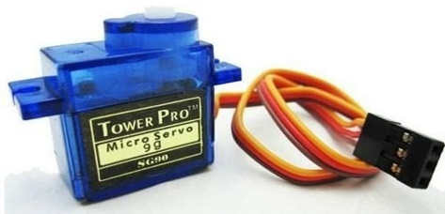

Fig. 3.1.1 Servo motor

# LCD DISPLAY:

# A 16x2 LCD means it can display 16 characters per line and there are 2 such lines. In this LCD each character is displayed in 5x7 pixel matrix. The 16 x 2 intelligent alphanumeric dot matrix display is capable of displaying 224 different characters and symbols.

# 

# Fig.3.1.2 LCD

# IR SENSOR:

Arduino IR Sensor Interfacing. An infrared proximity sensor or IR Sensor is an electronic device that emits infrared lights to sense some aspect of the surroundings and can be employed to detect the motion of an object. As this is a passive sensor, it can only measure infrared radiation.

# Image result for IR SENSOR

# Fig.3.1.3 IR sensor

# POTENTIOMETER:

# A potentiometer is a type of position sensor. They are used to measure displacement in any direction.

# 

# Fig. 3.1.4 Potentiometer

AURDUINO UNO:

The Arduino UNO is the best board to get started with electronics and coding. If this is your first experience tinkering with the platform, the UNO is the most robust board you can start playing with. The UNO is the most used and documented board of the whole Arduino family.

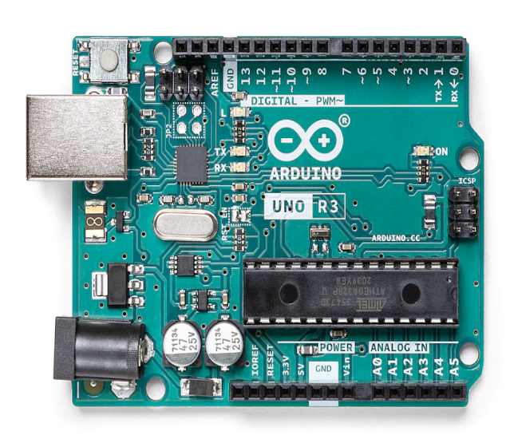

Fig.3.1.5 Arduino UNO

**3.2 CAR PARKING SYSTEM USING ARDUINO:**

The working concept of this involves 4 components: IR Sensor, Arduino board, Servo motors, and the LCD Display. The IR sensors are continuously scanning both sides of the crossing for cars so they can give an alert when the car is either coming or leaving.As soon as the car approaches a crossing from either side the command is sent to the Arduino board. The Arduino board upon receiving the command gives out the signal to the servo to open the crossing. The Arduino then gives out the command to LCD Display to either increase or decrease the number of empty slots. The whole process gets started again. This completes the working concept of this project.

**4.PROPOSED METHOD**

The proposed system for car parking using Arduino Uno relies on sensors and microcontroller technology to accurately detect the presence or absence of slots in parking areas. The system is designed to improve parking efficiency and reduce the time it takes to find an available parking space. Thus, the system consist of:Arduino UNO, servo motor, LCD, and IR sensor.

**4.1Working Principle**

Initially, +5V is given to the Arduino UNO then one of the two IR sensors are meant for detecting the entry of the car when the car crosses the first IR sensor the number of slots available decreases and the same is shown in the LCD. The another IR sensor detects the leaving of the car once the car crosses this sensor the available slots increases and the corresponding output is shown in the LCD. The servo motor acts as a gate for the entry and exit of the car. If there is no available slots the servo motor closes that not permitting the car.

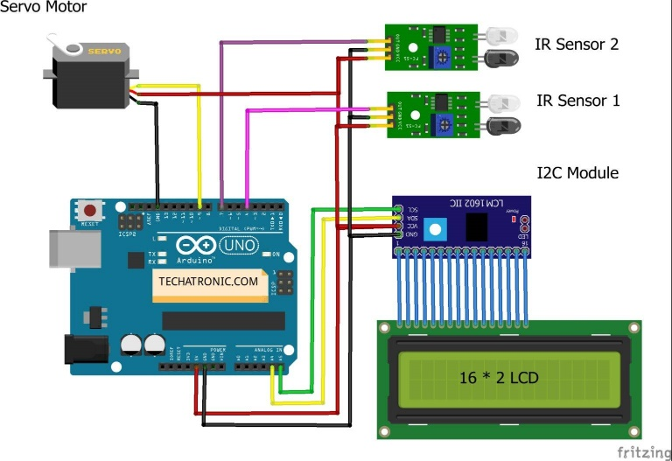

Fig 4.1 Circuit diagram

**5. RESULTS AND DISCUSSION**

The proposed system provides a real-time monitoring of parking spaces. This allows parking attendants to quickly identify which parking spaces are vacant and which are occupied, thus improving the overall efficiency of the parking system**.** Thus, saving the customers time for waiting at the parking points. The car parking system using Arduino provides a basic solution for automating the parking process. However, there are several limitations and areas of improvement that need to be considered. The current implementation of the car parking system using Arduino is limited to a small number of parking slots (up to four). Expanding the system to include a larger number of parking slots would require significant hardware and software modifications. The system does not include any security features to prevent unauthorized access to the parking slots. Adding security features such as a password-protected access system or RFID-based authentication would be necessary for a commercial implementation.

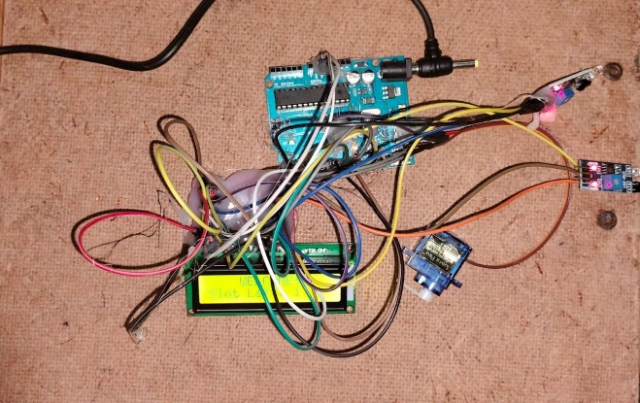

Fig 5.1 Hardware implementation of the proposed system

**6.CONCLUSION AND FUTURE SCOPE**

In conclusion, car parking systems using Arduino Uno have shown to be effective in improving parking efficiency and reducing the time it takes to find available parking spaces. These systems use sensors to detect the presence or absence of vehicles in parking spaces, and microcontroller technology to control and manage the parking system. In the future, there are several areas where car parking systems using Arduino Uno can be improved and expanded. For example: Integration with smart city technologies: Car parking systems can be integrated with other smart city technologies such as traffic management systems, to improve overall traffic flow and reduce congestion. Implementation of machine learning algorithms: Machine learning algorithms can be used to analyze parking patterns and optimize the use of parking spaces.

**REFERENCES**

[1]"Smart Parking System using Arduino and Ultrasonic Sensor" by N. Gupta, A. R. Siddiquee, and M. R. Hoque, 2017 IEEE Region 10 Conference (TENCON), 2017.

[2]"Real-time Car Parking System using Arduino Uno" by S. Singh and P. Singh, 2018 5th International Conference on Signal Processing and Integrated Networks (SPIN), 2018.

[3]"Smart Parking System using Arduino and GSM" by S. R. Chowdhury and S. Biswas, 2018 2nd International Conference on Computer, Communication, Chemical, Materials and Electronic Engineering (IC4ME2), 2018.

[4]"Automated Car Parking System using Arduino Uno and Android" by R. K. Jha, M. R. Hoque, and N. Gupta, 2018 3rd International Conference on Computing, Communication and Security (ICCCS), 2018.

[5]“IoT-based Smart Parking System using Arduino Uno" by P. Tiwari, S. Goyal, and P. Sharma, 2020 International Conference on Intelligent Sustainable Systems (ICISS), 2020.

[6]"Car Parking System using Arduino Uno and Infrared Sensors" by P. Kumar and P. Kumar, 2017 International Conference on Computing and Communication Technologies (ICCCT), 2017.

[7]"Smart Car Parking System using Arduino Uno and Bluetooth" by S. Singh and P. Singh, 2017 International Conference on Innovations in Information, Embedded and Communication Systems (ICIIECS), 2017.

[8]"Automatic Parking System using Arduino and Ultrasonic Sensor" by M. R. Hasan and A. Hossain, 2019 International Conference on Electrical, Computer and Communication Engineering (ECCE), 2019.

[9]“Smart Parking System using Arduino and RFID" by S. Chowdhury, S. Biswas, and T. Sen, 2018 International Conference on Computing, Power and Communication Technologies (GUCON), 2018.

[10]"Design and Implementation of a Smart Parking System using Arduino and ZigBee" by M. A. Ali, M. R. Hoque, and N. Gupta, 2018 4th International Conference on Electrical, Computer and Communication Technologies (ICECCT), 2018.